**Fact Sheet**

### Slide System

1. Load Inerta:
2. Transfer Function of the system
3. Sample Frequency:
4. Transfer Function of the controller
5. 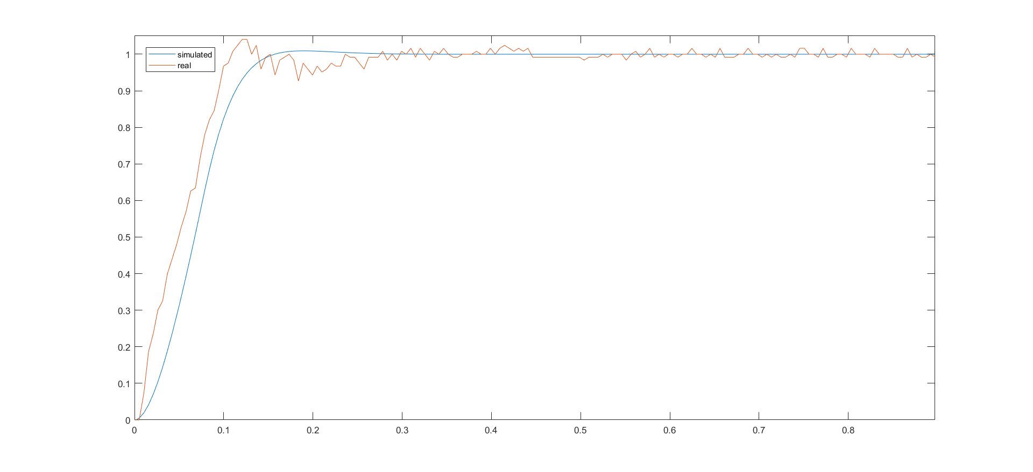Plots

## Conveyor Belt

1. Load Inertia:
2. Simulink Model:

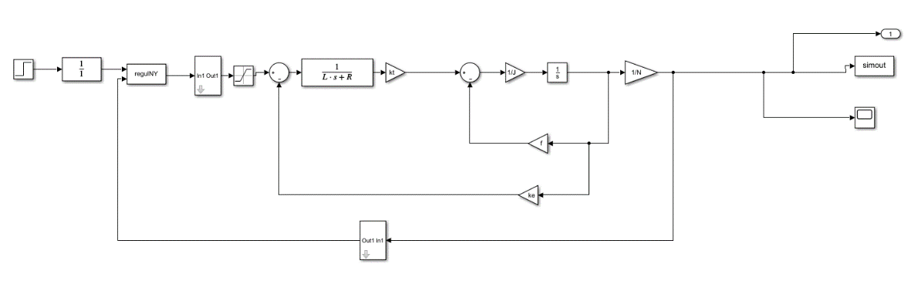

1. Transfer Function of the system
2. Sample Frequency:
3. Transfer Function of the controller
4. 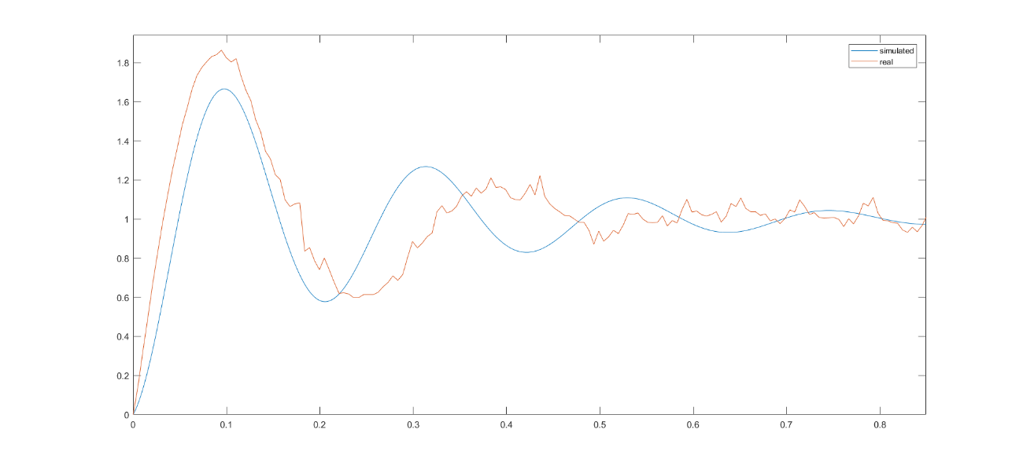Plots

Group 17

Jakob Løfgren and João Ramiro